Week 6 and 7 Virology

Introduction
This is a simulated prac using data have been taken from work undertaken in our laboratories or those of colleagues. You will be comparing 3 methods to identify COVID-19 infection in serum samples.

For this exercise, imagine that you are a member of a PC3 laboratory here in Sydney. Using full PPE, including a respirator, you have been asked to carry out an epidemiological investigation on recent suspected cases from UTS.

A group of students from a local high school began showing symptoms of COVID-19 infection. The students were referred to the COVID-19 clinic where the nurses collected blood samples and nasopharyngeal swabs (collected into virus transport medium). Of the students tested, one had been sick for 7-10 days (sample 1) and another reported mild symptoms (samples 2).

For this assessment we will be examining three different method. ELISA, serum neutralisation tests (also called a plaque reduction neutralisation assay) and immunofluorescence detection assays, to detect COVID-19. (In this exercise, you will not be performing qPCR).

The time between exposure to the virus and presentation of symptoms is typically 5 to 6 days, although this may range from 2 to 14 days. IgM and IgA antibodies to SARS-CoV-2 can be detected in serum at relatively low titres from around 5 days after symptom onset, while IgG antibodies can be detected after 14 days after symptom onset using several serological tests. Early in the course of infection, antibodies to the virus will largely be of the IgM class but some IgG will also be present. Detection of high IgM and low IgG titres is another method of inferring an active infection. Ideally, serological confirmation of a diagnosis requires paired serum samples taken two weeks or so apart with demonstration of a rising antibody titre. However, as this is time sensitive, we cannot wait the two weeks to confirm.

While highly suggestive, the presence of IgM antibodies to SARS-CoV-2 in a single test does not prove the diagnosis of the disease, as described above. Although unlikely, it is formally possible that persons have previously been exposed to a similar virus. Therefore, you will also attempt to isolate and identify the virus from the nasopharyngeal swabs in a human cell line followed by an immunofluorescence assay. After isolation, the virus should also be sequenced, however you will not be doing this in this prac. Lastly, you will investigate whether the antibodies in the patient serum are able to neutralise the virus, using a plaque reduction assay.

nbaeR*6A.9t.wXq
PART A: Enzyme Linked ImmunoSorbent Assay (ELISA)

In this ELISA the antigen is bound to a solid surface; in this case, a plastic 96 well plate. As it is too dangerous to use purified virus to coat plate, we will use recombinant S (spike) protein. The S protein is allowed to bind to the ELISA plate. Excess protein is removed, and the wells blocked with skim milk (an irrelevant protein, thus preventing other proteins in subsequent steps from sticking non-specifically to the plastic). Dilutions of test serum are then added to the wells of the plate, allowing any antibodies specific for the coronavirus S protein to bind. After washing, bound antibody is detected by addition of a polyclonal antiserum raised against human immunoglobulin (which recognises human IgG, IgA and IgM). This polyclonal anti-immunoglobulin is chemically conjugated to the enzyme horse radish peroxidase. After yet another washing step, bound antibody is detected by adding substrate plus a chromogen to produce a coloured reaction which can be quantitated spectrophotometrically.

Here are some basic YouTube videos to help you visualise the method.
https://www.youtube.com/watch?v=zR_xlV5v_f4
https://www.youtube.com/watch?v=YIc_3PTpNM8

Materials
- 96 well ELISA plate
- 96 well plate for preparing serum dilutions
- Patient serum sample 1; (heat-inactivated for 30 minutes to inactivate the virus)
- Patient serum sample 2; (heat-inactivated for 30 minutes to inactivate the virus)
- Positive control serum (anti-corona virus serum); diluted 1/50 (heat-inactivated)
- Negative control serum; diluted 1/50 (heat-inactivated)
- Corona virus antigen (S protein) 5µg/ml
- 5% skim milk powder (w/v) in phosphate buffered saline (PBS).
- PBS/Tween 20 (0.05% w/v)
- Goat-anti-human antibody conjugated to horse radish peroxidase (HRP) diluted 1:1000
- Chromogen (ABTS) 1 mg/ml in citrate/phosphate buffer pH 4 (note ABTS powder is a mutagen). ABTS=2,2’-azino–bis(3-ethylbenzothiazoline-6-sulfonic acid).
- Substrate (Hydrogen peroxide)

Method
1. 50ul of a mix containing 5ug of the coronavirus S protein in 5ml of carbonate buffer is added to each well of the ELISA plate and incubated at 4ºC overnight.

2. The antigen is removed, and 100µl of 5% skim milk powder in phosphate buffered saline (PBS) added to each well. The plate is incubated overnight.

3. Dilutions of serum samples and controls are performed in the second 96 well plate. You will be performing half-log serial dilutions. To the 96 well plate add 100μl of milk/PBS to each of wells A-H of columns 1-4. To well A column 1 add 46.25 μl of the sample 1 serum. Perform 46.25µl into 100µl serial dilutions (using a new pipette tip, mix, and then remove 46.25 μl to well B, repeat for well C etc. to well H). In column 2 repeat (using a clean tip) for sample 2. Continue, using column 3 for the positive control serum dilutions and column 4 for the negative control serum dilutions.

4. Empty the blocking buffer from the ELISA plate by flicking it out, and banging the plate dry over paper towels.
5. Set up your ELISA plate by leaving column 1 blank. The dilutions of Sample 1 are added to wells A to H of column 2 and column 3, by removing 50μl of each dilution into the appropriate well in column 2 and in column 3 to provide duplicate column. Hint: if you start at column H you will not need to change pipette tips (going from lower dilution to higher dilutions). Sample 2 dilutions are then added to columns 4 and 5, positive controls to columns 6 and 7 and negative controls to columns 8 and 9. Incubate the plate for 60 minutes at 37ºC.

6. As there is a small possibility that infections virus was still present in the serum, remove the media with a multi-channel pipette and discard the contents of the wells into a solution of fresh bleach, then wash each well four times with 400μl of PBS/Tween 20. Make sure the wells are completely empty after the last wash, and add 50μl of anti-human HRP conjugate diluted in milk/PBS to each well and incubate for 30 minutes at 37ºC.

7. Flick out the antiserum and wash the wells 6 times with PBS/Tween 20. Add 100μl of substrate (ABTS 1 mg/ml in citrate phosphate buffer pH 4 containing 0.06% v/v hydrogen peroxide) to all wells including column 1.

8. Read plates at 405nm on a microplate reader after 20 minutes incubation at room temperature.

Result:
TBA

PART B: Serum Neutralization test (plaque reduction assay)

Serum neutralisation assay measures the ability of the antibodies in the test serum to neutralise coronavirus. Serum is diluted, 1/10, 1/20, 1/40 in media and incubated with a known number of plaque forming units of virus. After 60 minutes of incubation, the virus-serum mixture is plated onto Vero cell monolayers in 24 well plates, and the virus allowed to adsorb to the cells for 90 minutes. The virus-serum mixture is then aspirated to remove unabsorbed virus and unattached antibody, after this 1ml of cell culture medium is added to each well. The plates are then incubated for 3-4 days by which time plaques should be visible as holes in the cell monolayer where virus replication has killed the cells. As you are handling an infectious virus, you will perform this experiment in a class II safety cabinet, within biosafety-level 3 facility, wearing full protective gear (which looks very much like a space suit).

Here is a YouTube video to help you visualise the method.
https://www.youtube.com/watch?v=er2dwOPwSRo

Materials
- Vero cell monolayers in 24 well plates.
- Minimal essential medium (MEM) for cell cultures. This is supplemented with 2% foetal calf serum, 2mM L-glutamine and antibiotics.
- 250ul Serum samples from patient 1 and patient 2 .
- 250ul Negative control patient serum (diluted 1/20)
- Corona virus at a concentration of approximately 750 plaque forming units per ml.
- 14 sterile eppendorf tubes
- 10% formalin
- Crystal violet solution

Method
Note: as these cultures will be incubated for 3-4 days in rich culture medium, stringent aseptic technique is CRITICAL.

1. In disposable tubes, prepare 160μl of 1/10, 1/20 and 1/40 serum dilutions for each of the three serum samples.

2. Mix 160μl of each serum dilution with 160μl of the diluted virus preparation. As additional controls, mix 250μl of the virus with 250μl of medium for the "virus only" control, and prepare one tube with 500μl of medium for the "no virus control".

3. Vortex the tubes and incubate at 37ºC for 60 minutes.

4. After incubation, aspirate the medium from the cultured cells, and add 150μl samples from each tube to the appropriate monolayers in the 24 well plate. [Note: take care not to disrupt the monolayer when aspirating and pipetting. Do not leave the monolayers without liquid for more than 30 seconds, or the cells will die.] Dilutions of samples from patient 1, patient 2 and negative control sera are to be tested in duplicate. The "no virus" control and the "virus only" control samples are to be tested in triplicate. Ensure that the cell monolayers are completely covered by the inoculum.

5. Incubate for 90 minutes 37ºC 5% CO2.
6. Gently remove the media from the monolayers and replace with 1ml of MEM. On top of that an agar overlay is added to prevent spread of the virus in the medium.

7. Incubate the plates at 37ºC 5% CO2 for 6 to 7 days.

Suggested layout:
Row A: Duplicates of patient 1 serum dilutions.
Row B: Duplicates of patient 2 serum dilutions.
Row C: Duplicates of the negative control serum dilutions.
Row D: Three wells of the "virus only" control, three wells of the "no virus" control.

Inspect plates for plaque formation before staining. Aspirate medium from wells (this contains live virus, place in the disinfectant provided). Add 200μl of 10% formalin to each well to fix the monolayers. Leave for 10 minutes then aspirate the formalin and add 100μl of crystal violet solution. Leave for 20 minutes then gently wash the monolayers in tap water to remove excess stain. Drain onto paper towel.

Result

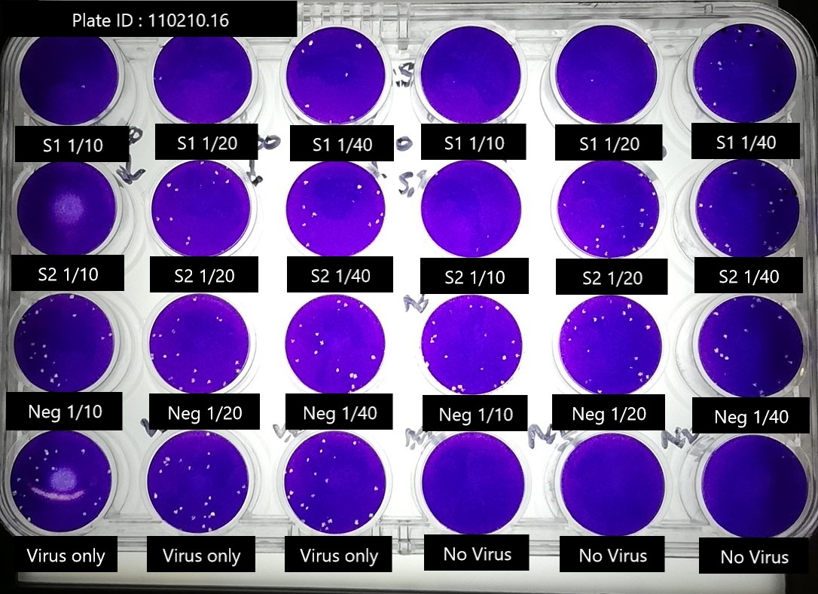

Figure 1: Viral plaque plate 1

Week 7: Fluorescent antibody staining of virus-infected cultures (immunofluorescence assay)

You will use Vero cells to determine if virus can be cultured from the tissue sample collected from patient 1’s nasopharyngeal swab. Antibiotics and antifungal agents will be added to the tissue cultures to help minimise bacterial and fungal growth. Stringent aseptic technique is still important. Virus infection of cell monolayers can be detected by the cytopathic effects of the virus. However, this does not tell you with any certainty what virus is present. In this case we will examine the monolayers for Vero, infected with coronavirus, using specific human antibodies to coronavirus which binds to viral proteins. You will then detect this binding with an anti-human immunoglobulin conjugated to FITC, which fluoresces under UV light.

Materials
- Vero cell monolayers in 24 well plates
- Minimal Essential Medium (MEM)
- Nasopharyngeal swab sample in virus transport medium.
- coronavirus
- 1:1 v/v Methanol:Acetone
- serological pipettes
- Dissecting microscopes
- PBS/BSA =bovine serum albumin 3%w/v in PBS
- Anti-corona virus serum diluted 1/20
- Negative control serum (normal human serum) diluted 1/20
- Goat-anti-human-IgG-FITC (pre-diluted 1/70)

Method
1. Aspirate the medium from the monolayers, and add 150μl of samples as follows: A1 negative control (MEM), A2 swab sample, A3 positive control virus. Duplicate this for A4, A5 and A6. Incubate the monolayers for 60 minutes 37.C 5% CO2.

2. Gently aspirate the inoculum and replace with 1ml of MEM. Incubate for 3-4 days until the cytopathic effect can be seen in the monolayers.

3. Aspirate the MEM and add 200μl of 1:1 v/v methanol/acetone to each monolayer to fix and permeabilise the cells. Leave for 10 minutes. Aspirate the fixative.

4. Wash the monolayers 3 times with 1 ml of PBS/BSA.

5. Add 50μl of anti-corona virus serum to each well in columns 1, 2 and 3.

6. Add 50μl of normal human serum to each well in columns 4, 5 and 6.

7. Incubate 37ºC for 30 minutes.

8. Aspirate the serum from the wells. Wash each well 3 times with 1 ml of PBS/BSA.

9. Add 50μl of goat-anti-human-IgG-FITC to each well. Incubate for 30 minutes at room temperature in the dark.
10. Aspirate and wash monolayers 3 times with 1 ml PBS/BSA. View plates using a fluorescent microscopy.

Results:

(A1) Undiluted negative control with anti-Corona virus serum | (A2) Undiluted swab sample with anti-Corona virus serum | (A3) Undiluted positive control with anti-Corona virus serum
 | 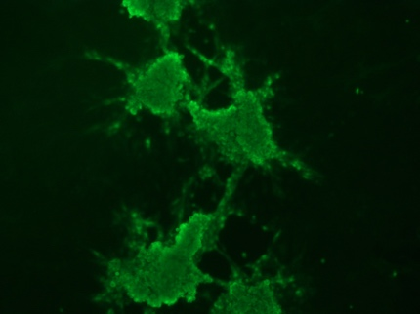 | 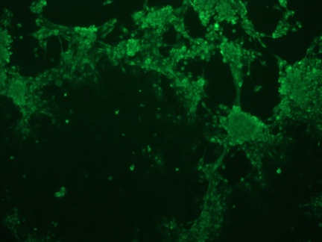
(A4) Undiluted negative control with negative control serum | (A5) Undiluted swab sample with negative control serum | (A6) Undiluted positive control with negative control serum.
 |  | 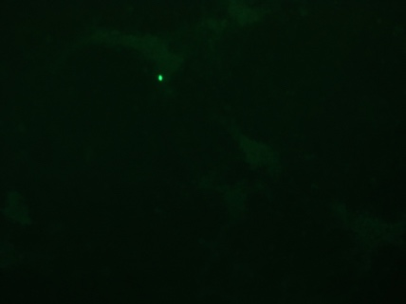
Figure 2: Images of swab samples under a fluorescence microscope.

Assessment: You will write this prac (week 6 and 7) up as your scientific report answering the questions below.

- Provide a flow diagram for the method of Part A.

- Document the mean absorbance for each sample and controls using data provided in Table 1
Dilution | Sample 1 | Sample 2 | Positive control | Negative control

- Plot graphs of the mean of the duplicate absorbance vs log dilution for all samples using Table 1.

- Calculate the antibody titres by picking an absorbance reading in the linear part of the curve. The absorbance value you choose should be at least 0.1 units above the negative control serum absorbance at a dilution of 1/100. The antibody titre is the reciprocal of the dilution of antibody giving your chosen absorbance value. (In order to make a valid comparison, the same absorbance value must be used for all curves).

- What issues could arise if we were to use the N protein as antigen in our ELISA instead of S protein?

- Provide a flow diagram for the method of Part B.

- Count plaques in all wells in Figure 1. Calculate the percentage plaque reduction at each serum dilution and estimate the titre. If there are virus specific neutralising antibodies in the serum sample the number of plaques will be reduced compared to the same amount of virus incubated without serum. Antibody titre in this assay is normally reported as the reciprocal of the serum dilution giving a 50% reduction in plaque number. This may need to be calculated by interpolation. An alternative is to use the highest serum dilution giving a plaque reduction of 50% or greater.

- Provide a flow diagram for the method of Part C.

- Briefly explain the outcome for each image (1 –2 sentences each).

- Briefly describe what information is gained through the techniques of part A, B and C. How is this different to the knowledge gained from PCR?

- Which method, if any, gives the truest measurement of anti-coronavirus antibodies? Explain.

- How might we determine if one of the patients is infected but not yet showing symptoms, or if they have previously been exposed to the Sars Cov2 virus?

- You are preparing to present this work as a paper. Write an abstract complete with title for your paper based on this data.

